use Customer

db.orderSummary.insertOne({

customer_id:1,

name:"Abhijeet",

age:20,

city:"Pune",

purchase_date: new Date("2024-10-01"),

purchase_amount:1,

purchased_product:"Lenovo Gaming Ideapad"})

db.orderSummary.insertMany([{

customer_id: 2,

name: "Gunjan",

age: 21,

city: "Mumbai",

purchase_date: new Date("2024-10-03"),

purchase_amount: 2,

purchased_product: "HP Pavilion x360"

},

{

customer_id: 3,

name: "Nikhil",

age: 20,

city: "Pune",

purchase_date: new Date("2024-10-05"),

purchase_amount: 1,

purchased_product: "Apple MacBook Air"

},

{

customer_id: 4,

name: "Yash",

age: 20,

city: "Mumbai",

purchase_date: new Date("2024-09-28"),

purchase_amount: 3,

purchased_product: "Dell Inspiron 15"

},

{

customer_id: 5,

name: "Rajat",

age: 20,

city: "Pune",

purchase_date: new Date("2024-09-30"),

purchase_amount: 1,

purchased_product: "Acer Nitro 5"

},

{

customer_id: 6,

name: "Pratham",

age: 21,

city: "Ahemdabad",

purchase_date: new Date("2024-10-02"),

purchase_amount: 1,

purchased_product: "Asus ROG Zephyrus"

}])

db.orderSummary.find({purchase_amount : {$gt :1}})

db.orderSummary.updateMany({city:"Mumbai"},{$set:{city:"Pune"}})

db.orderSummary.deleteMany({city:"Ahemdabad"})

db.orderSummary.find({$or:[{age:20},{age:21}]})

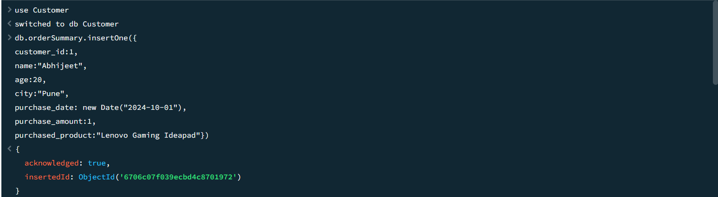

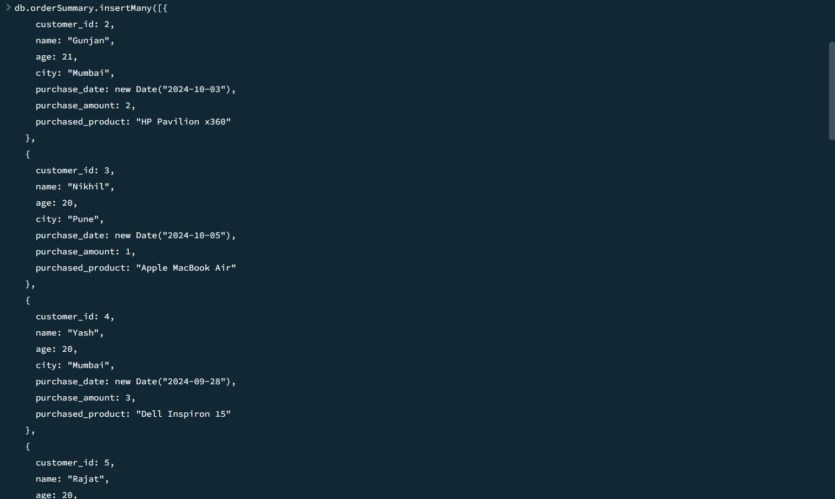

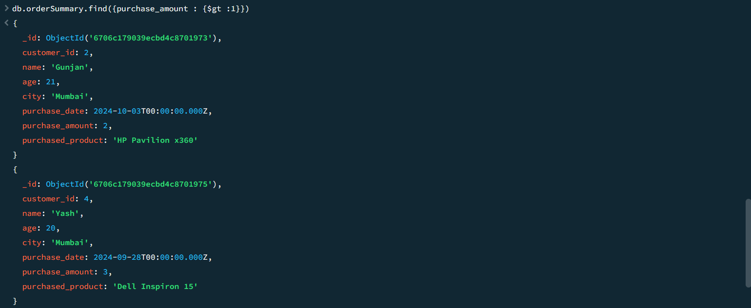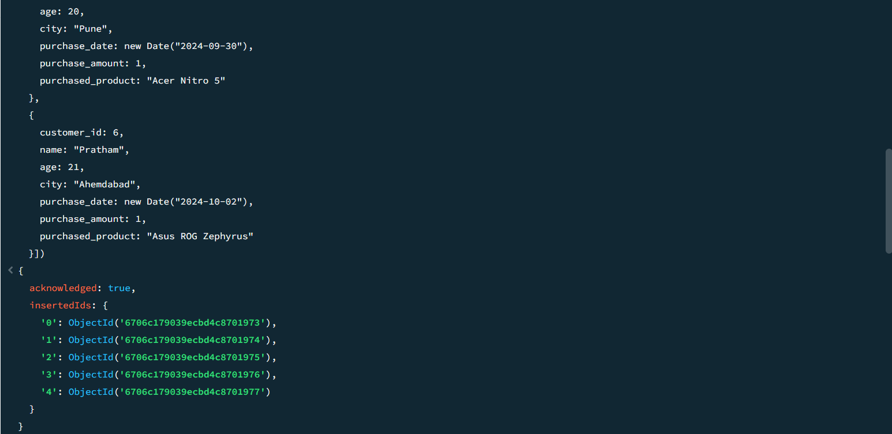

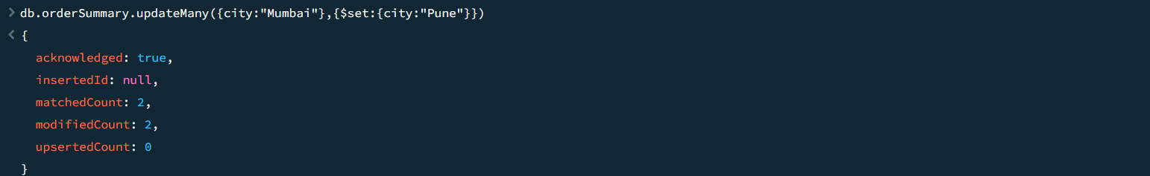

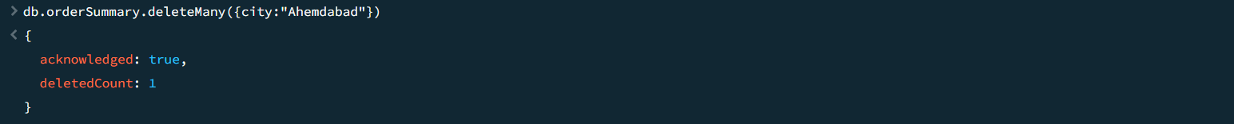

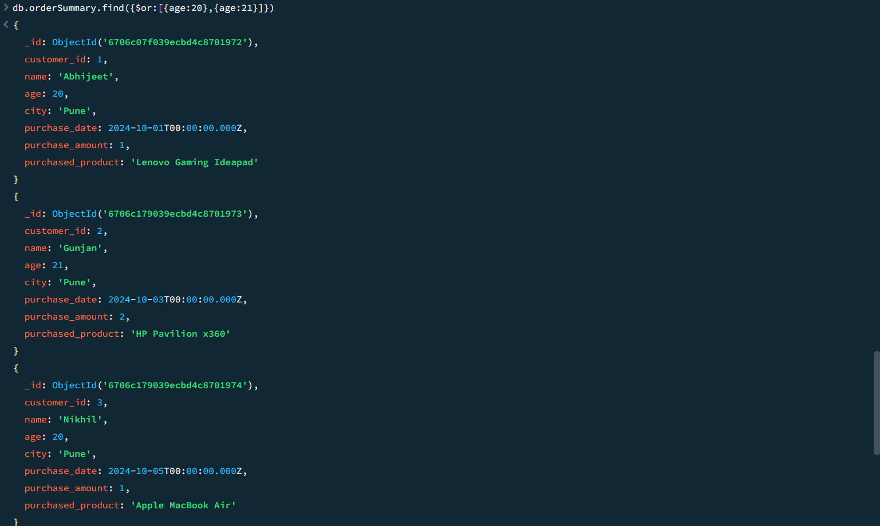

4TH

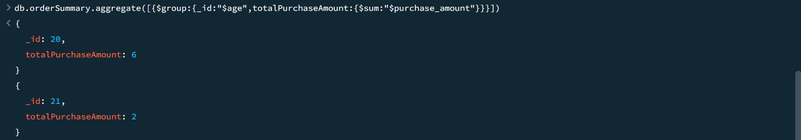



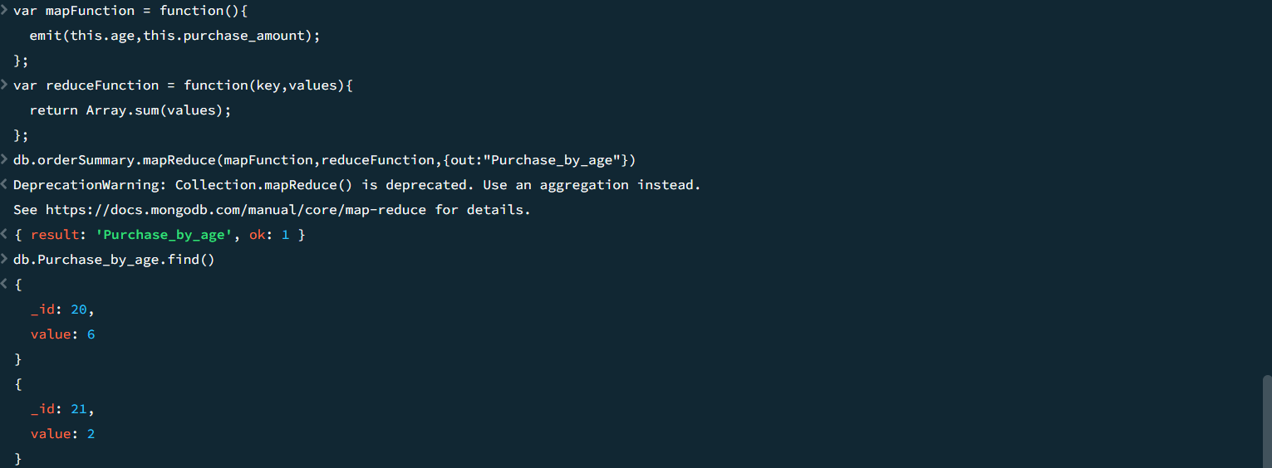  
5th  


SELECT * FROM users

INTO OUTFILE 'C:/ProgramData/MySQL/MySQL Server 8.0/Uploads/users.csv'

FIELDS TERMINATED BY ','

ENCLOSED BY '"'

LINES TERMINATED BY '\n';  
  
SELECT * FROM users  
INTO OUTFILE ‘'C:/ProgramData/MySQL/MySQL Server 8.0/Uploads/users.txt'  
FIELDS TERMINATED BY ‘\t’  
LINES TERMINATED BY ‘\n’;  


LOAD DATA INFILE 'C:/ProgramData/MySQL/MySQL Server 8.0/Uploads/users.csv'

INTO TABLE users

FIELDS TERMINATED BY ','

ENCLOSED BY '"'

LINES TERMINATED BY '\n';  


LOAD DATA INFILE ‘C:/ProgramData/MySQL/MySQL Server 8.0/Uploads/users.txt'  
INTO TABLE users  
FIELDS TERMINATED BY ‘\t’  
LINES TERMINATED BY ‘\n’;